AI Assisted Coding Lab 7.3
Name: A.Yashwanth
2303A52432
Batch:42
Task 1: Fixing Syntax Errors
Scenario
You are reviewing a Python program where a basic function definition contains a syntax error.
Requirements
- Provide a Python function add(a, b) with a missing colon
- Use an AI tool to detect the syntax error
- Allow AI to correct the function definition
- Observe how AI explains the syntax issue
Prompt : I have a Python function that won't run. Can you identify the syntax error in this code .
Code :
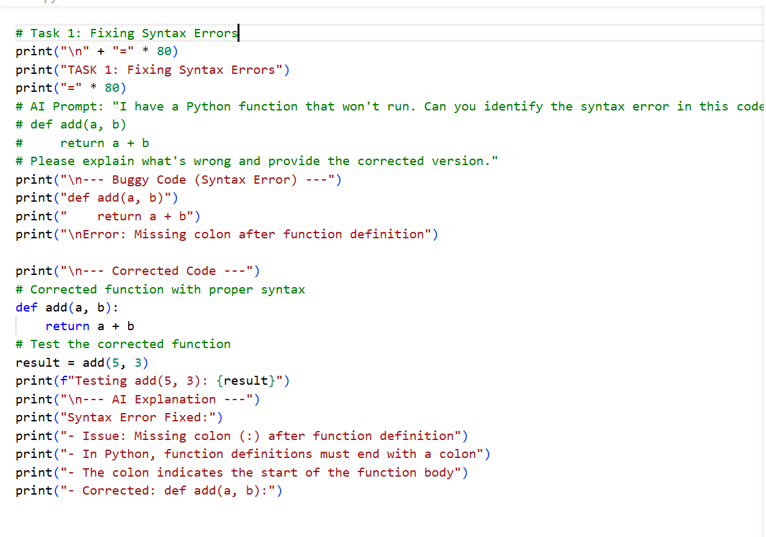
OUTPUT:
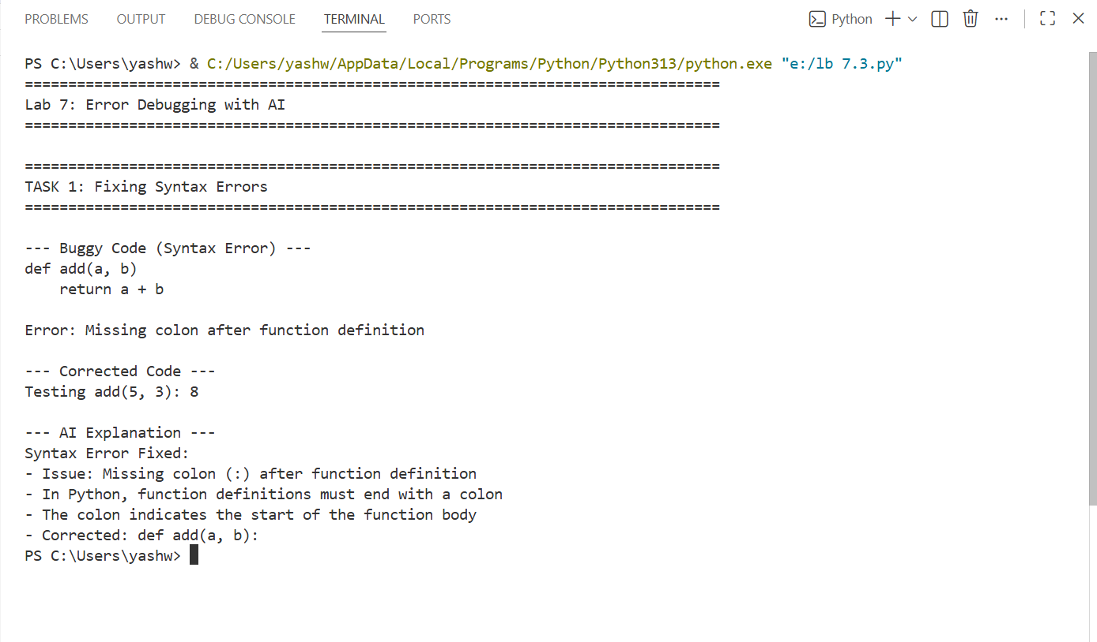
Justification :
This task is justified because syntax errors prevent a program from running at all. Learning to identify and correct syntax mistakes (such as missing colons or indentation issues) helps ensure code follows Python’s grammatical rules and builds attention to detail when writing valid programs.
Task 2 : Debugging Logic Errors in Loops
Scenario
You are debugging a loop that runs infinitely due to a logical mistake.
Requirements
- Provide a loop with an increment or decrement error
- Use AI to identify the cause of infinite iteration
- Let AI fix the loop logic
- Analyze the corrected loop behavior Prompt :
This loop is running infinitely. Can you identify the logic error .
Code :
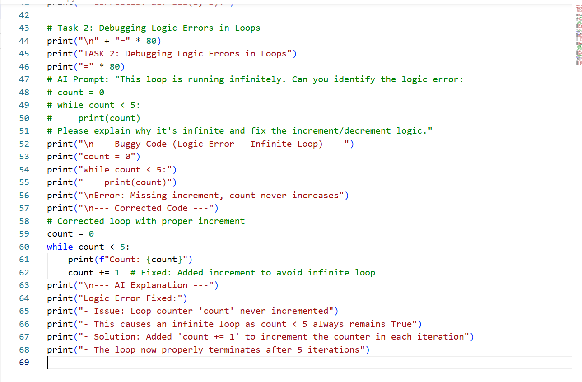
OUTPUT:

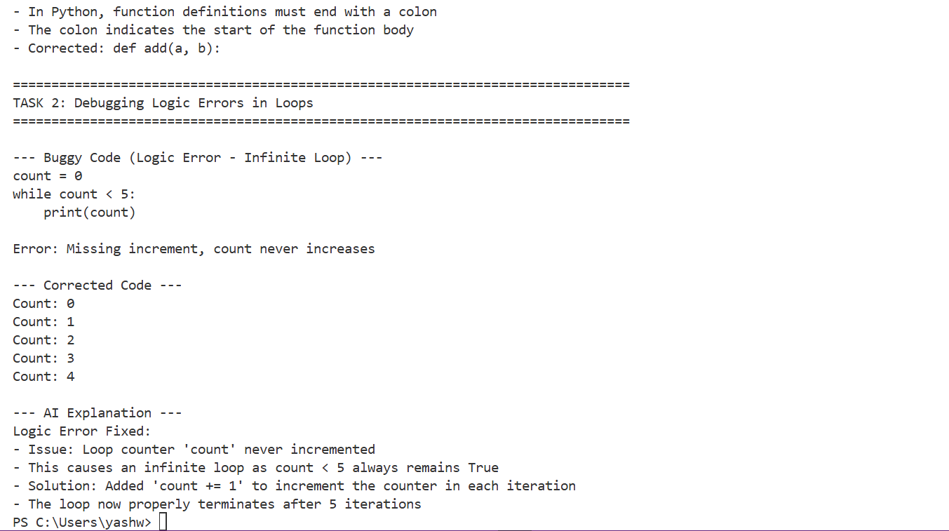
Justification :
This task is important because logic errors allow a program to run but produce incorrect or unintended behavior, such as infinite loops. Debugging these issues develops critical thinking and improves understanding of program flow and loop control.
Task 3 : Handling Runtime Errors (Division by Zero)

Scenario
A Python function crashes during execution due to a division by zero error.
Requirements
- Provide a function that performs division without validation
- Use AI to identify the runtime error
- Let AI add try-except blocks for safe execution
- Review AI’s error-handling approach
Prompt : This function crashes with division by zero. Can you help fix it .
Code :
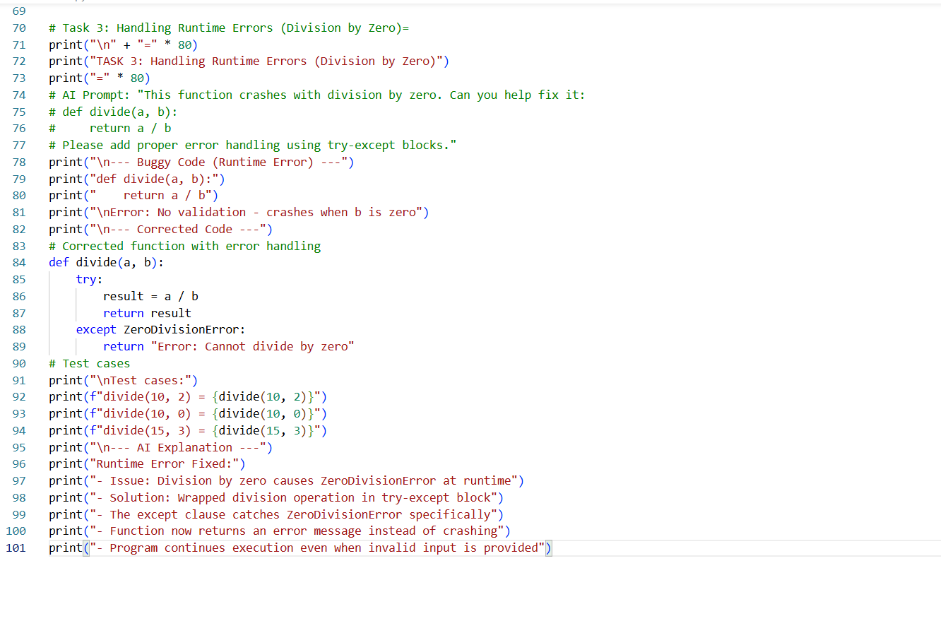
OUTPUT:
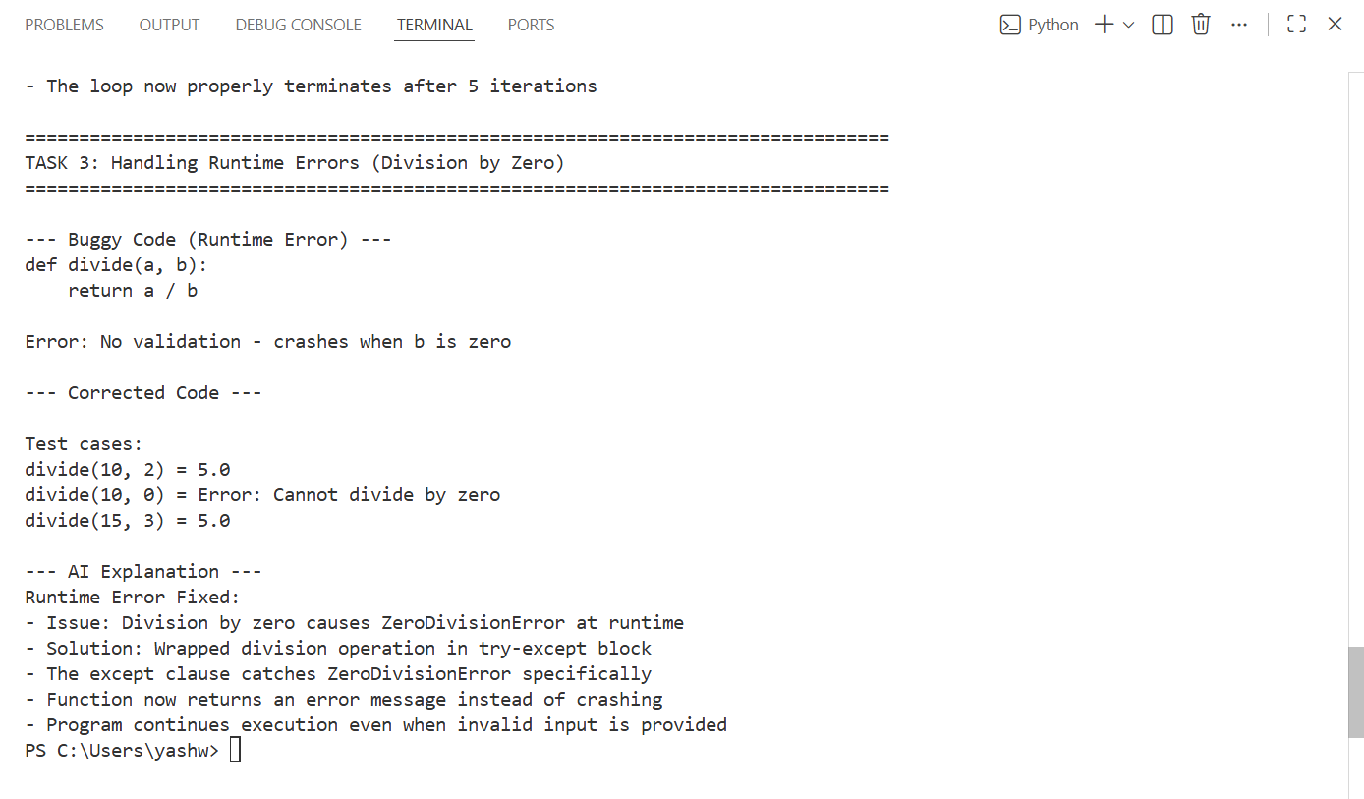
Justification :
This task is justified because runtime errors occur during execution due to unexpected inputs or operations, like division by zero. Adding error handling increases program reliability and teaches defensive programming to prevent crashes.
Task 4 : Debugging Class Definition Errors
Scenario
You are given a faulty Python class where the constructor is incorrectly defined.
Requirements
- Provide a class definition with missing self-parameter
- Use AI to identify the issue in the __init__() method
- Allow AI to correct the class definition
- Understand why self is required
Prompt : My Python class won't work. What's wrong with this code .
Code :
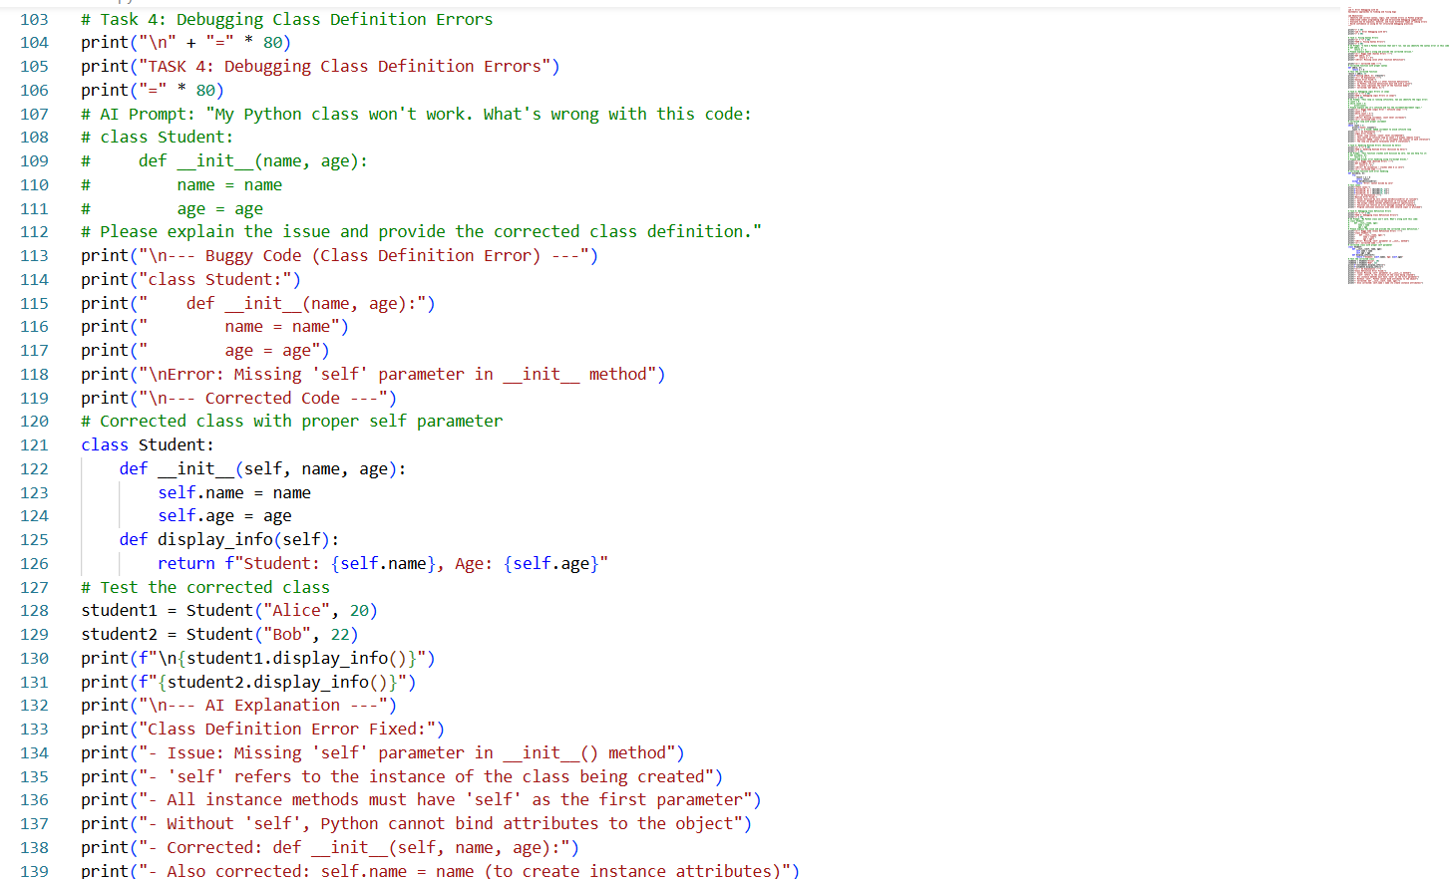
OUTPUT: 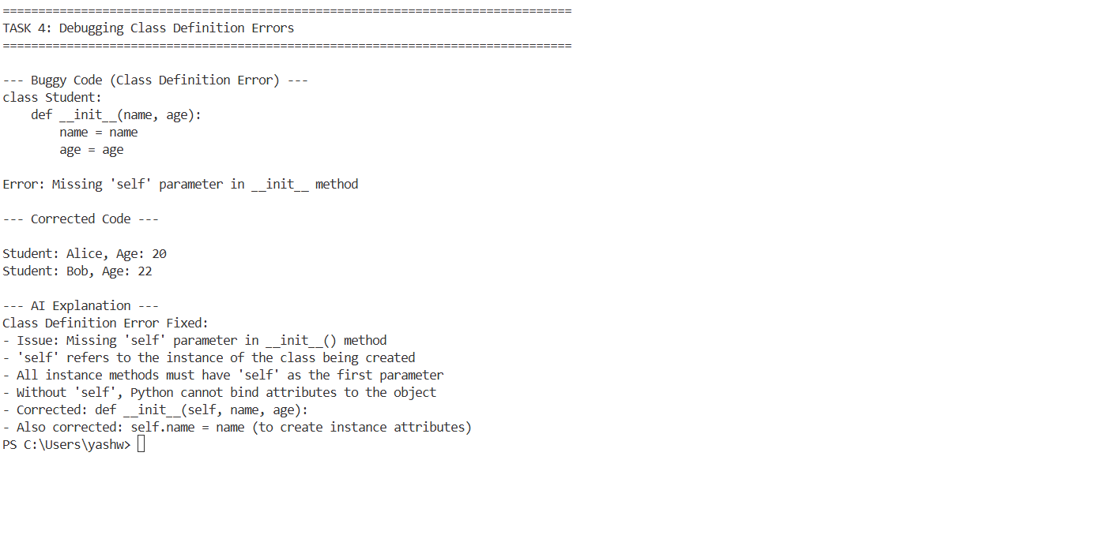
Justification :
This task is necessary to reinforce correct object-oriented programming practices. Understanding the role of self ensures that instance attributes are properly stored and accessed, which is essential for creating functional and maintainable classes.
Task 5 : Resolving Index Errors in Lists
Scenario
A program crashes when accessing an invalid index in a list.
Requirements
Provide code that accesses an out-of-range list index
Use AI to identify the Index Error
Let AI suggest safe access methods
Apply bounds checking or exception handling
Prompt : My program crashes with an IndexError. Can you fix this code .
Code :
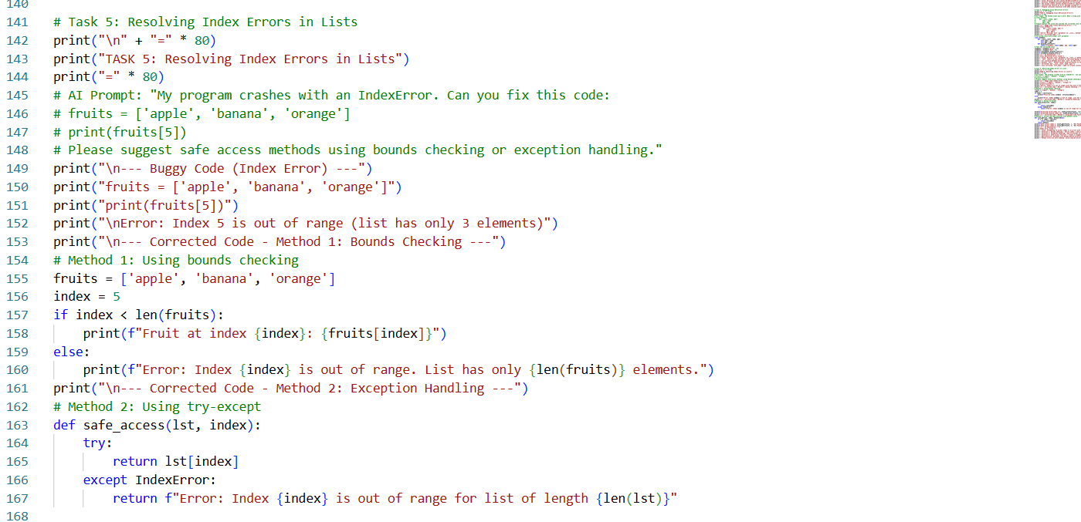
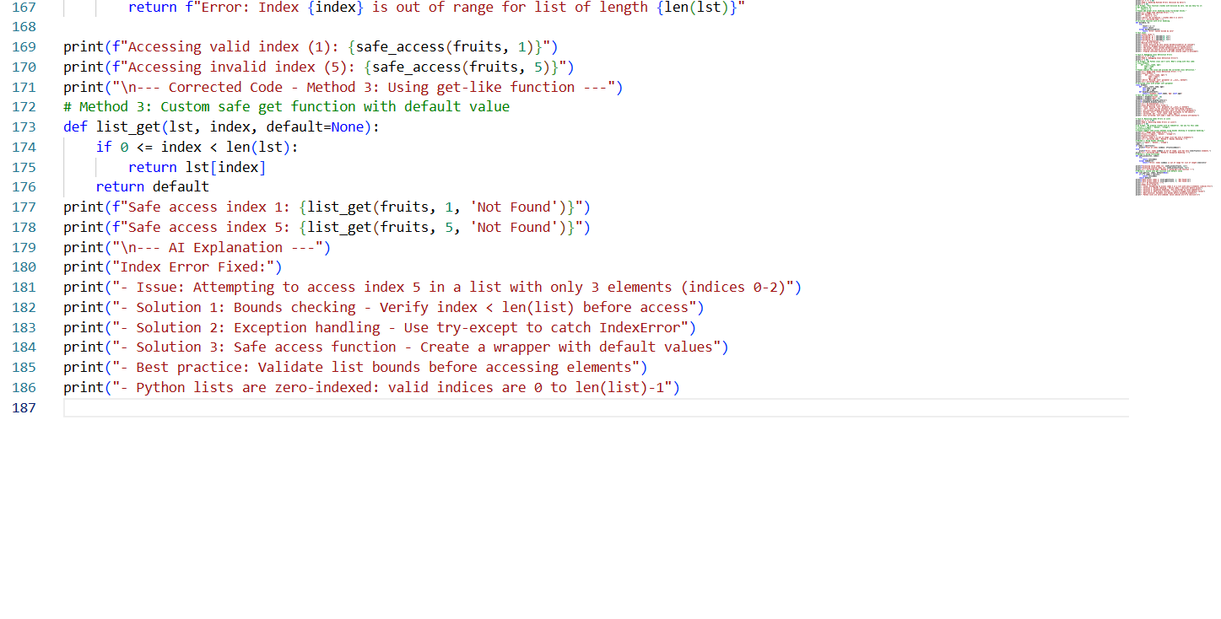
OUTPUT: 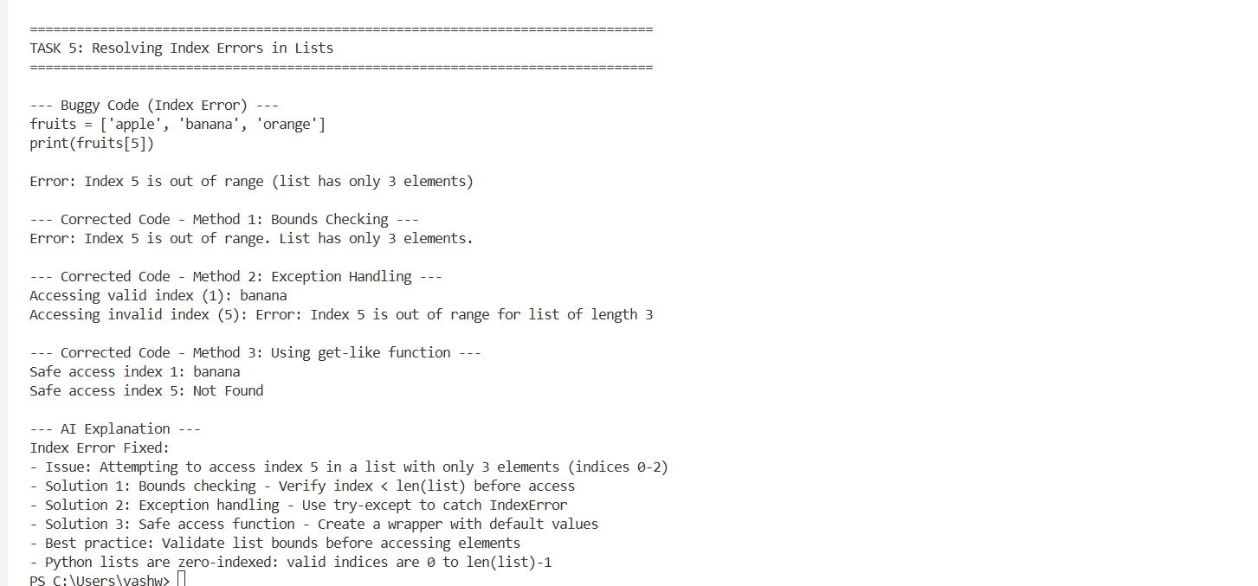
Justification :
This task is justified because accessing invalid indices is a common source of crashes. Learning bounds checking and safe access methods improves data safety, prevents errors, and promotes writing more robust code
